Syllabus:-
What is HDFS?
What is Block?
Replication and Replication Factor?
Over Replication and Under Replication
HDFS Write Flow?
HDFS Read Flow
HDFS Commands

Datasets:-
https://github.com/cfamilyIN/data

Link to setup Bigdata Virtual Machine:-
https://www.cfamily.com/apache-hadoop-and-spark-vm/course/

What is HDFS?
- HDFS – Hadoop Distributed Filesystem.
- In HDFS Filesystem File divided into multiple blocks.
- Each block size until Hadoop 1.x – 64MB from Hadoop 2.x – 128MB
300MB/128MB ➔ 3Blocks
B1—128Mb
B2—128MB
B3 – 44MB
- Hadoop replicates each block 3times
- DataNode is responsible for storing.
- How NameNode decides where to store block?
In Hadoop, There is one important algorithm called “Proximity Algorithm”.
Proximity Algorithm has
Data Centre Details
Rack Details
Node Details
Ethernet Bandwidth
- Most of the time administrators write proximity algorithm in python scripting
- HDFS Filesystem is a User space. Normal Filesystem loads as part of Operating System Process but HDFS Filesystem loads as part of User Process.
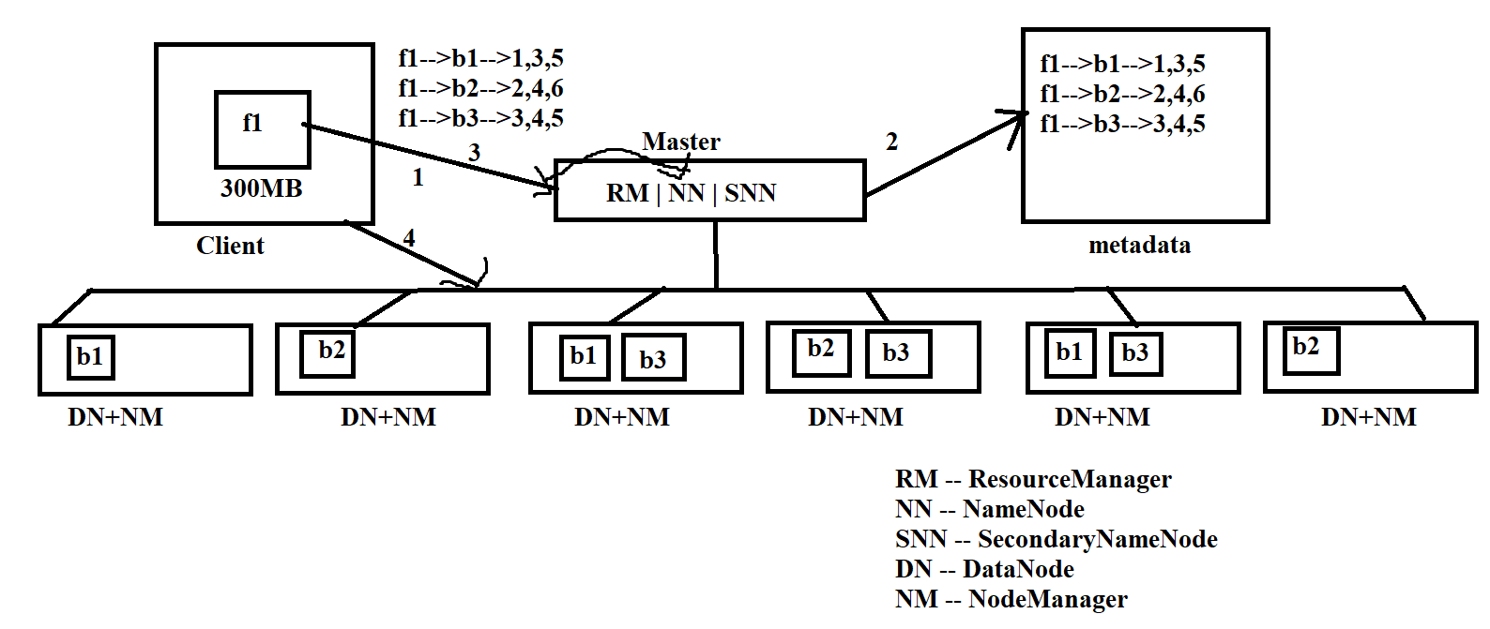
What is HDFS Block:-
- Block is a chunk of data or peace of data.
- Normal Filesystem is not Distributed, so it will not store in multiple machines, it will store in a single. Normal Filesystem block size is 4KB in Old operating Systems and 8KB in new Operating systems. So seeking time (reading) is slow in normal filesystem
- HDFS Block is
Until Hadoop 1.x – 64MB
From Hadoop 2.x – 128MB

- HDFS Blocks are distributed across the cluster.
- Normal Filesystem loads as part of Operating System Process but HDFS Filesystem loads as part of User Process. So we can customize HDFS Block. We can increase or Decrease HDFS Filesystem size in “hdfs-site.xml”
Default is 128MB
dfs.blocksize | 134217728 | The default block size for new files, in bytes. You can use the following suffix (case insensitive): k(kilo), m(mega), g(giga), t(tera), p(peta), e(exa) to specify the size (such as 128k, 512m, 1g, etc.), Or provide complete size in bytes (such as 134217728 for 128 MB).

hdfs-site.xml
<configuration>
<property>
<name>dfs.blocksize</name>
<value> here we can specify custom size</value>
</property>
</configuration>
- The main advantage of bigger block size is seeking time (read) is very faster.
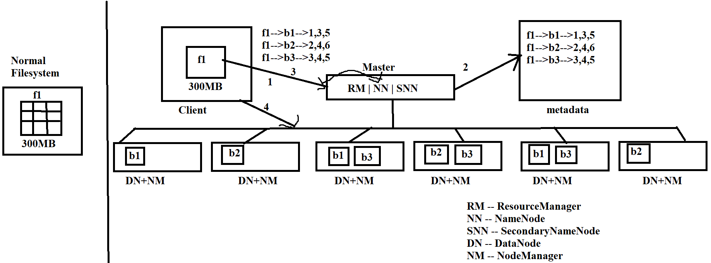

What is Replication and Replication Factor:-
- Replication means duplicate copy
- Replication-Factor mean How many duplicate copies of each is called Replication Factor.
- The Default replication factor is ‘3’.
- We can increase or decrease based on our requirement.
dfs.replication | 3 | Default block replication. The actual number of replications can be specified when the file is created. The default is used if replication is not specified in create time.
- We can change replication value in hdfs-site.xml
hdfs-site.xml
<configuration>
<property>
<name>dfs.replication</name>
<value>3</value>
</property>
</configuration>

Under Replication:-
- If any machine down then the block under that machine comes to under replication.
Blocks < Replication-Factor
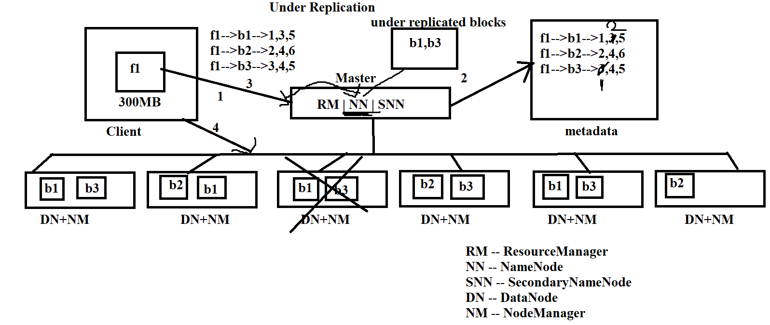
How NameNode knows about Failed Machines?
- Every DataNode sends heart beat signal
dfs.heartbeat.interval | 3 | Determines datanode heartbeat interval in seconds.
- If NameNode not receives heart beat signal from Any of the DataNode then it marks that machine as Down.

What will happens in Under replication situation?
- NameNode asks other machines to create under replicated blocks.
- If DataNode’s replicated then NameNode updates metadata.

Over Replication:-
- If any blocks > Replication Factor is called Over Replicated Blocks.
- After some failed machine issue is resolved and it become up, then it starts sending heart beat signal to its master called NameNode
- NameNode verifies Meta data then it identifies these blocks are Over Replicated Blocks.
- Then NameNode will ask DataNode machines to remove b1,b3
B1- 1,2,3,5
B3—1,3,4,5
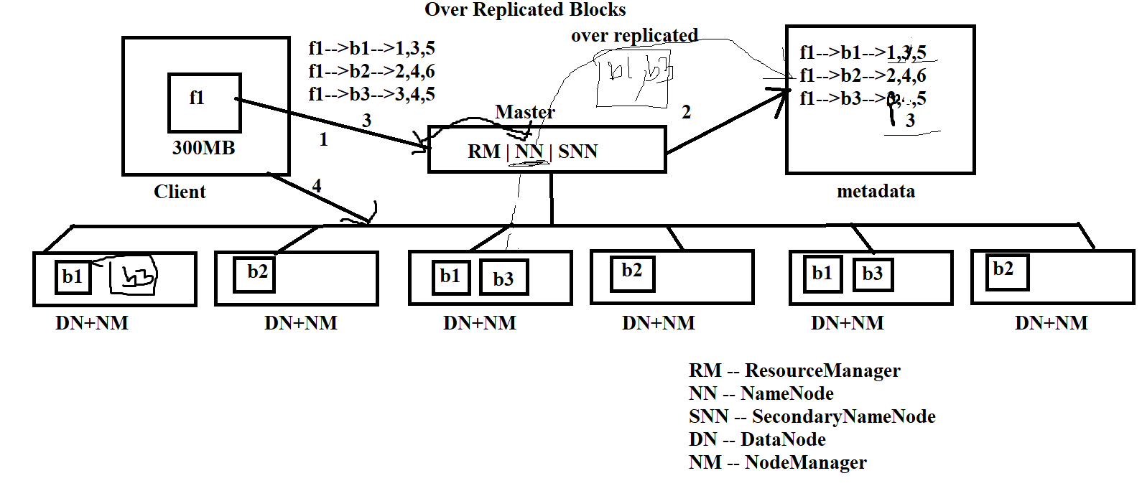
What will happens in Over Replicated Blocks?
- NameNode asks DataNode’s to remove over replicated blocks.
- Any Machine which has over replicated blocks may accept and removes.
- Then NameNode Updates metadata.

HDFS Write Flow:-
- When Client wants to write data into HDFS Filesystem – HDFS Write Flow will happen.
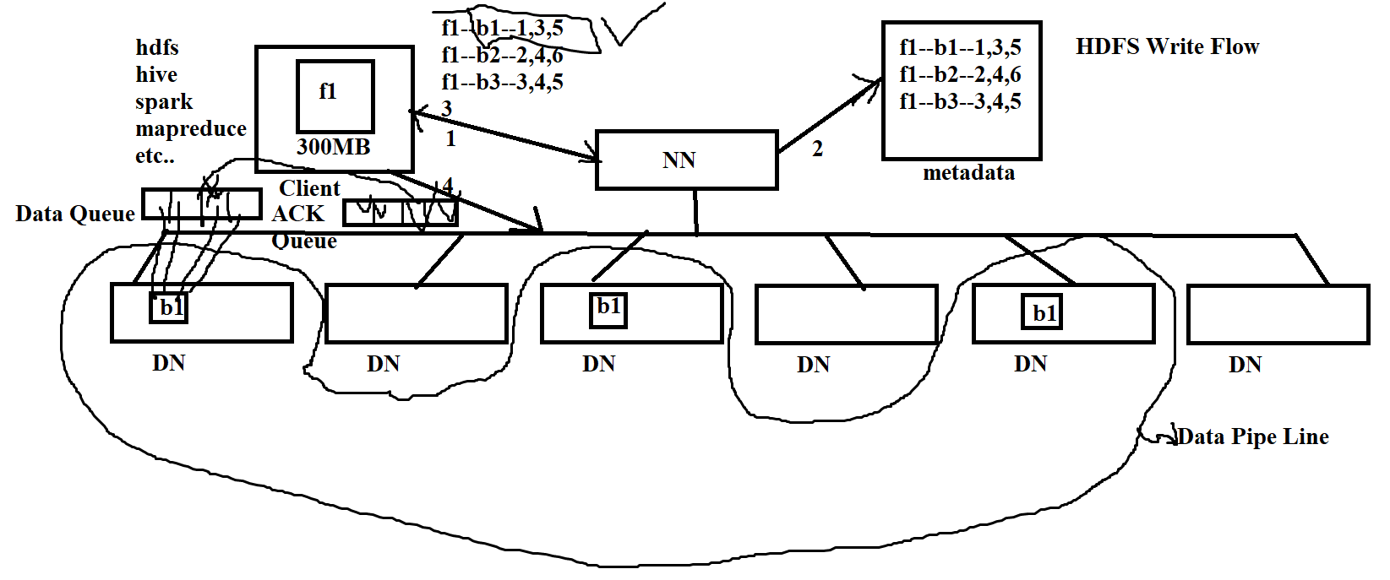

HDF Read Flow:-
- When Client Wants to read data from HDFS Filesystem (Client May be HDFS Command, MapReduce, Apache Pig, Apache SQOOP, Apache Hive, Apache Spark, Apache Flink, Apache Beam, Any Hadoop Client) then HDFS Read Flow happens
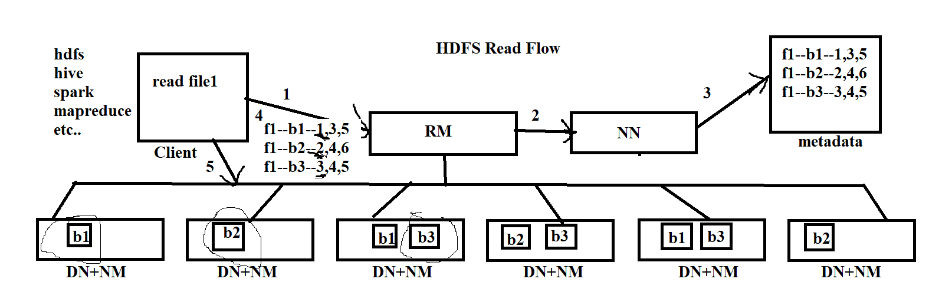

By
Akkem Sreenivasulu – Founder of CFAMILY
eMail : info@cfamily.com
Contact: +91-9133161144
Website: www.cfamily.com
Telegram: https://t.me/cfamilyIN
YouTube: www.youtube.com/cfamily
Facebook: https://www.facebook.com/cfamilyIN/
LinkedIn : https://www.linkedin.com/in/cfamily
Instagram : https://www.instagram.com/cfamilyin/
Twitter : https://twitter.com/cfamilyIN
GitHub: https://github.com/cfamilyIN/

